EnderGreen: Enhancing Solar Panel Efficiency and Energy Management Through IoT in Smart Homes

Amnay Mou   
Dalian Polytechnic University   
*DPU*Dalian, China  
amnaymou.org@gmail.com

*Abstract*— EnderGreen is a forward-thinking initiative that seamlessly integrates smart home IoT technologies with sustainable energy management, offering households the tools they need to optimize their energy consumption and reduce their carbon footprint within the framework of smart cities and homes. This innovative system dynamically adjusts home energy usage in response to overcast weather and battery levels falling below 50%, utilizing real-time weather data and IoT sensors to conserve energy by dimming lights and powering down devices. Homeowners can conveniently monitor their solar panel operations, including battery life, solar output, and current weather conditions, through the EnderGreen app, which also suggests the most efficient energy mode based on these factors. Enhanced accuracy and responsiveness are achieved with additional sensors continuously tracking energy production and battery levels, envisioning a future where solar energy and IoT technology harmoniously coexist to create sustainable smart homes and cities.

Keywords— green IoT, Smart home, IoT, Sustainable energy management, Energy consumption, Carbon footprint, Smart cities.

# Introduction

In the era of smart homes, the convergence of cutting-edge technology and sustainability has become increasingly vital, with the conversion of solar energy to electrical energy through photovoltaic cells now of great interest not only to developed nations but also to developing nations, driven by the environmental and economical merits attached to it as an alternative source of energy that is cheap, clean, and inexhaustible [1]."EnderGreen" is a groundbreaking proposal that seeks to revolutionize energy management in smart homes through the utilization of Internet of Things (IoT) technology. The primary focus of this proposal is to empower homeowners with efficient and eco-friendly energy management tools, ultimately reducing their carbon footprint while optimizing energy usage.

Smart cities are evolving at a rapid pace, and one of their key components is smart homes. These homes are equipped with various IoT devices and sensors that enable automation and remote control of appliances, lighting, and HVAC systems. However, the efficient utilization of renewable energy sources, such as solar panels, is often overlooked. EnderGreen aims to bridge this gap by integrating IoT technology into the energy ecosystem of smart homes.

The proposed system leverages real-time data from weather sensors to assess environmental conditions, including cloud cover. When the weather is cloudy and the battery charge falls below 50%, EnderGreen automatically switches the home to an economy energy mode. This mode includes adjustments like decreasing lighting levels and turning off unused devices, ensuring energy conservation during suboptimal solar conditions.

Furthermore, the EnderGreen APP provides homeowners with a user-friendly interface to monitor the performance of their solar panels. It displays critical information such as battery levels, solar panel productivity, and current weather conditions. By factoring in weather data, the app suggests the most efficient energy mode for the home, enhancing energy management and promoting sustainability.

To enhance the system's accuracy and responsiveness, EnderGreen incorporates additional sensors to detect energy productivity in Watts per hour and monitor battery levels. These sensors provide real-time data to ensure precise energy management decisions.

In this proposal, EnderGreen represents a significant step towards greener and more efficient smart homes within the context of smart cities. By seamlessly integrating IoT technology, solar panels, and weather data, this proposal empowers homeowners to make informed decisions about their energy usage while reducing their environmental impact. EnderGreen envisions a future where smart homes contribute to a sustainable and eco-conscious society.

To further empower homeowners, we're considering the inclusion of an energy savings calculator within the EnderGreen app. This calculator would allow users to estimate potential cost savings and environmental benefits, which can be a motivating factor for more sustainable energy consumption. How much could you save on your energy bills while reducing your carbon footprint by optimizing your energy usage? This exciting idea opens the discussion to even greater possibilities in the realm of smart home energy management.



*Fig1. IoT Concept Transformation into Entity-Based Model . (CM → RM)*

# Methods

This section covers the Ender Green app integration process in depth, with an emphasis on system, software, and hardware integration. Our smart home energy management concept mostly relies on the Android app Ender Green. It provides homeowners with the potential to maximize energy use, lower their carbon footprints, and improve sustainability. We will also include instructive app samples to highlight its salient features and demonstrate how well it aligns with the objectives of our proposal.

## Hardware Integration:

As the eyes, ears, and energy source of our smart house, sensors and solar panels are essential components of our energy management project. Every sensor has a distinct function and adds to the accurate data gathering required for sustainable and well-informed energy management. Our solar panels, which are the mainstay of our renewable energy approach, simultaneously capture solar energy and transform it into clean energy. These sensors and panels work together as the fundamental components of data gathering and energy production, which is essential for maximizing energy efficiency and advancing sustainability in our smart homes.

|  |  |  |  |
| --- | --- | --- | --- |
| Type | Name | Range | Parameter |
| Battery detect level | DC 8-120V Battery Capacity Tester | 8V to 120V 50A (0 to 75A) | Monitors voltage and current in the 8-120V range, essential for assessing battery health and capacity in your energy management system. |
| Photodiode Sensor | SSR2AD Solar Radiation Sensor (Model:SSR2AD) | 0 to 2000 W/m² or higher | Measures solar radiation for solar energy assessment. |
| Passive Infrared (PIR) Motion Senso | HC-SR501 PIR Motion Sensor | Typically, up to 6 meters (20 feet) | Detects human motion and occupancy in its field of view. |
| Digital Temperature and Humidity Sensor | DHT22 (AM2302) Sensor | Temperature range of -40°C to 80°C, Humidity range of 0-100% | Provides temperature and humidity data for indoor environmental control. |
| Current Sensor | SCT-013 Current Transformer | Up to 100A AC current | Monitors electricity usage by measuring current flow in circuits. |
| Carbon Dioxide (CO2) Sensor | MH-Z19C NDIR CO2 Sensor | 0 to 5000 ppm | Measures carbon dioxide levels in the indoor environment. |
| Gas Detection Sensor | MQ-7 Carbon Monoxide (CO) Gas Sensor | 10 to 300 ppm (parts per million) | Detects carbon monoxide gas levels, indicating potential health hazards. |

The *'Battery Capacity Tester'* ensures the health and efficiency of our power storage systems, guaranteeing uninterrupted energy supply. Meanwhile, the *'Solar Radiation Sensor'* provides essential data for harnessing solar energy by measuring solar radiation intensity. Our *'PIR Motion Sensor'* enhances security and energy efficiency by detecting human presence to activate lighting and appliances only when needed. The *'Digital Temperature and Humidity Sensor'* keeps indoor environmental conditions optimal, thereby minimizing energy usage for heating and cooling. On the safety front, the *'Gas Detection Sensor'* monitors carbon monoxide levels to safeguard occupants from potential health hazards. The *'Carbon Dioxide (CO2) Sensor'* contributes to better indoor air quality and the *'Current Sensor'* empowers homeowners with insights into electricity consumption, motivating them to adopt energy-efficient practices. Together, these sensors are the building blocks of data collection, playing a pivotal role in optimizing energy usage and promoting sustainability in our smart homes.

## Software Integration:

Ender Green's software integration is the linchpin of our smart home energy management system, meticulously designed to optimize sustainability and user-friendliness. This comprehensive software architecture is divided into several crucial components, each playing a distinct role in achieving our energy management objectives.

Ender Green is adapted to Android devices in a fluid manner, guaranteeing compatibility with a wide range of Android OS versions. Our sustainable energy management solution is now more accessible to a wider range of consumers thanks to this compatibility.

Central to our system's success is the robust connectivity with IoT devices and sensors. Ender Green leverages secure protocols and APIs to enable real-time data collection from our network of interconnected hardware components. At the core of our software lies advanced data processing and analysis. Ender Green's algorithms and logic enable real-time interpretation of

sensor data, empowering the application to make informed decisions on the fly. Our interface ensures that users have the power to manage their energy resources in an informed and user-centric manner. Ender Green boasts a user-friendly and intuitive interface, offering homeowners interactive dashboards and control panels.

Our software component orchestrates various systems within the smart home, including lighting, HVAC, and appliances. It operates based on data collected from sensors and aligns with user preferences to ensure optimal energy management. Ender Green maintains an open line of communication with users, providing real-time notifications to enhance the user experience. From energy-saving recommendations to alerts regarding battery levels, weather conditions, or sensor anomalies, our app keeps homeowners well-informed and in control of their energy management. The security and privacy of user data are paramount in Ender Green. Our software integrates robust security features, including encryption, authentication, and authorization protocols, to safeguard sensitive data and protect the smart home system from potential cyber threats.

By integrating with the cloud, Ender Green expands its capabilities and offers remote control and optimization of energy systems. Leveraging advanced technologies like machine learning, the app predicts usage patterns, enhancing energy efficiency and sustainability. Regular updates and maintenance ensure app reliability and compatibility, fostering informed energy decisions and environmental responsibility in smart cities.

Ender Green is a cutting-edge application developed using a combination of industry-leading software development technologies. Our development team utilized a stack of programming languages, including Python, Java, and JavaScript, to ensure versatility and robust functionality. The app is built on a solid foundation, making it compatible with both Android platforms, providing a wide reach to homeowners.

For seamless integration with IoT devices and sensors, we harnessed the power of popular IoT platforms such as AWS IoT and Google Cloud IoT. These platforms enable secure data exchange and efficient communication with the smart home ecosystem, enhancing user control and data analysis. Additionally, we employed agile development methodologies and continuous integration tools like Jenkins and Git for efficient project management, ensuring regular updates, security enhancements, and a seamless user experience.

In the development of the Ender Green app, our team employed a range of powerful software development tools to ensure efficiency and precision. Android Studio, a widely recognized integrated development environment (IDE), played a pivotal role in crafting the Android version of our application. With its robust set of features, Android Studio enabled us to create a seamless and user-friendly experience for Android users. Microsoft Visio was instrumental in creating detailed diagrams and flowcharts to illustrate the app's connectivity with IoT devices and sensors in the Ender Green ecosystem. This streamlined our development process and enhanced team communication.

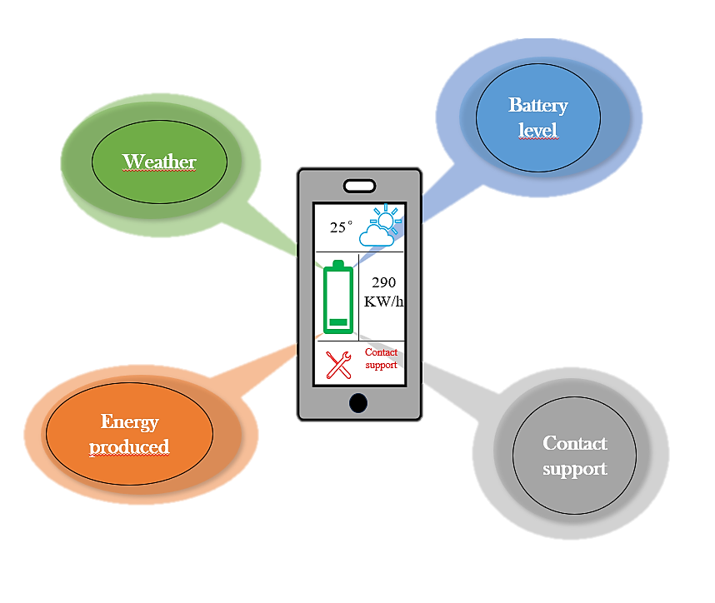

## System Integration

The Ender Green app is the linchpin of our sustainable energy management proposal, seamlessly fitting into the broader system designed to create eco-friendly and efficient smart homes within the context of smart cities. Its central role lies in dynamically adjusting home energy usage, primarily derived from solar panels, in response to real-time data from weather sensors and IoT devices. Ender Green ensures that homeowners can harness the full potential of their solar panels while promoting sustainability.

Within the smart home ecosystem, the Ender Green app acts as the orchestrator of various energy-consuming systems, including lighting, HVAC, and appliances. It operates based on a constant stream of data gathered by sensors, weather conditions, solar panel productivity, and battery levels. Through secure communication channels, the app interfaces with smart devices, making real-time adjustments to enhance energy efficiency and sustainability. It ensures that the home's energy management is in sync with user preferences, creating a seamless and user-centric experience.

The app's data integration is a vital component of our proposal. It collects real-time data from IoT sensors and weather sensors, constantly evaluating environmental conditions, including cloud cover and battery levels. This data serves as the foundation for Ender Green's real-time decision-making process. When unfavorable weather conditions are detected, and the battery charge falls below a certain threshold, the app automatically switches the home to an economy energy mode. This mode includes energy-saving adjustments like dimming lights and powering down unused devices, ensuring efficient energy management.

To accomplish the main objectives of the proposal, the Ender Green app is essential. By promoting real-time, data-driven energy management, it substantially reduces the carbon footprint of smart homes and optimizes energy usage. Homeowners can monitor and control their energy consumption, harnessing solar energy when it's most abundant and conserving energy during suboptimal conditions. This intelligent approach to energy management not only reduces environmental impact but also leads to cost savings, enhancing the overall sustainability and efficiency of smart homes within the broader context of smart cities.

# Understanding solar panel systems and energy production

Solar panels serve as the bedrock of EnderGreen's mission to enhance energy efficiency and sustainability in smart homes. Understanding the intricacies of solar panel efficiency is fundamental to comprehending the potential benefits of our energy management solution. In this section, we explore the factors affecting solar panel efficiency and how these insights directly inform EnderGreen's approach to energy optimization. By grasping the significance of solar panel efficiency, you'll be better equipped to evaluate the advantages of our smart home solution.

## Solar panel efficiency

* Solar panel efficiency: what is it?

Solar panels generate energy from sunlight, and their efficiency depends on the quality of their photovoltaic (PV) cells. Efficiency is measured by the percentage of sunlight converted into usable electricity. High-efficiency panels produce more energy per unit of sunlight, reducing space requirements.

* How efficient are solar panels?

Solar panel efficiency has improved significantly, with high-efficiency panels now reaching nearly 23%. Efficient panels reduce the number needed and overall costs, making solar energy more appealing.

* What factors affect solar panel efficiency?

Efficiency is influenced by factors like light reflection, sun intensity, cloud cover, and heat buildup. Panel design, color, inclination, and materials also play a role.

* Do solar panels lose efficiency over time?

Solar panels gradually degrade, producing around 90% of their original output after 20 years.

* Do solar panels work in cold weather?

Solar panels work in cold weather, with ideal conditions during cold, sunny, and windy days. Pairing panels with battery storage ensures consistent power.

* Do solar panels work in the rain?

Yes, solar panels work in the rain and can benefit from rain cleaning.

* Enhancing Solar Panel Understanding:

Understanding solar panel capacity is vital for EnderGreen's energy management solution. In the UK, a typical three-bedroom home consumes 3,000 kWh annually, aligning with 3kW to 4kW panel arrays.[2]

* Daily Solar Panel Output:

A high-efficiency SunPower Maxeon 5 AC panel can yield 1.76 kWh per day in regions with 4.25 hours of daily sunshine.

* Calculating the Number of Solar Panels:

An average UK household using 7.2 kWh per day requires about 17 SunPower Maxeon 5 AC panels. The actual number may vary by location and household size. [3]

* Realistic Energy Expectations:

Realistic expectations are key. Even the best panels may not cover all energy needs, especially in winter. Solar battery storage enhances efficiency.

## Solar Panel Efficiency and Its Relevance to EnderGreen

1. *How Much Electricity Should a Solar Panel System Produce?*

The amount of electricity generated by a solar panel system is typically measured in kilowatts (kW) per hour (kWh). For instance, a standard 4kW system typically produces approximately 3,400kWh of electricity annually. In the UK, where EnderGreen is poised to make a significant impact, a common three-bedroom household consumes just over 3,000kWh of electricity per year. Therefore, solar panel arrays in the UK are often designed with capacities of 3kW to 4kW, closely aligning with the energy demands of households.

1. *Daily Solar Panel Output*

The daily energy production of a solar panel system hinges on several critical factors, including the panel's efficiency and the duration of daily sunshine. Take, for example, the high-efficiency SunPower Maxeon 5 AC solar panel, boasting an impressive efficiency rating of 22.60%. In a region with an average daily sunshine duration of 4.25 hours, this solar panel can generate a daily output of around 1.76 kilowatt-hours (kWh) of electricity. This insight underscores the impact of geographic location and panel efficiency on daily energy production.

1. *Calculating the Number of Solar Panels*

Determining the number of solar panels required to meet your household's monthly electricity needs is contingent upon your energy consumption patterns. For an average UK household consuming around 7.2 kWh of electricity per day, a straightforward division can estimate the number of SunPower Maxeon 5 AC panels necessary to fulfill daily demand. In this case, it would require approximately 17 panels [4].

Keep in mind that the specific quantity of panels needed may vary based on factors such as your location, household size, and local weather conditions. The size and orientation of your roof also play a role in determining the optimal number of panels for your situation.

1. *Realistic Energy Expectations*

It's vital to establish realistic expectations regarding solar energy systems. Even the most efficient solar panels may not entirely cover a household's energy consumption, particularly during the winter months when daylight hours are shorter. Consequently, many homes with solar panels remain connected to the national grid, drawing power when necessary. For those who wish to rely predominantly on solar energy, investing in a solar battery to store surplus energy can be a wise choice.

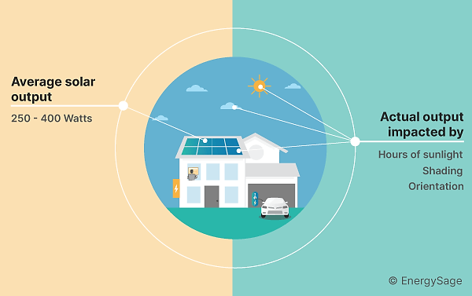

# Exploring the EnderGreen App Interface and Features

In this section, we will take a closer look at the EnderGreen app, delving into its intuitive interface and powerful features designed to make smart energy management a seamless experience for homeowners.

## Start layout

The initial layout of the EnderGreen app presents a clean and inviting design, featuring the EnderGreen logo against a backdrop that exudes a sense of environmental harmony. A single 'Start' button takes center stage, providing users with a seamless entry point into the app's journey, leading them to the login page upon activation.

## Login

The login layout is designed with user convenience in mind, offering two input fields for a username and product serial number. Users can also review and accept the terms and conditions via a checkbox. Once the required information is entered and the checkbox is marked, clicking the 'Login' button initiates the verification process. If the provided username and serial number match our database records, users are seamlessly directed to the information page, ensuring a secure and efficient login experience.

## Information

Here, users can easily get up-to-date information about their surroundings, such as the weather (for every day of week), city facts, where they are right now.

as well as the length of battery life of their home energy system. Additionally, they can monitor the amount of electricity their solar panel installation generates.

Additionally, a direct support call option is implemented for instant assistance, guaranteeing users a smooth and responsive way to handle any questions or problems. This design improves user experience and makes sure our users are always informed and connected by acting as the hub of information.

The Information Hub, located at the center of our app, gives consumers a centralized platform to access

# Result:

To sum up, EnderGreen redefines smart home energy management with an innovative combination of technology and sustainability. This innovative project addresses the pressing demand for eco-friendly solutions in the era of smart cities by enabling households to minimize their carbon footprint and maximize energy utilization.

With the use of IoT sensors and real-time weather data, EnderGreen can intelligently alter its energy use, saving electricity in cloudy conditions and when batteries are running low. The intuitive software gives energy-saving suggestions and gives users information on how well solar panels are performing.

Better precision and responsiveness from energy and battery level sensors set the stage for a time when solar energy and IoT will cohabit peacefully in sustainable smart cities and households. To evaluate cost savings and environmental advantages, the plan also considers the introduction of an energy savings calculator.

In conclusion, EnderGreen is a critical step toward smart houses in smart cities that are eco-friendlier and more productive, promoting a sustainable and environmentally conscientious future. It is an excellent example of how IoT technology and solar panels may be combined to create a more intelligent, sustainable, and greener future by enabling users to make informed decisions, lessen their carbon footprint, and make a positive impact on the environment.

##### References

1. Khan, N.; Sudhakar, K.; Mamat, R. Role of Biofuels in Energy Transition, Green Economy and Carbon Neutrality. Sustainability 2021, 13, 12374. [Google Scholar] [CrossRef]J. Clerk Maxwell, A Treatise on Electricity and Magnetism, 3rd ed., vol. 2. Oxford: Clarendon, 1892, pp.68–73.
2. https://corporate.enelx.com/en/question-and-answers/are-solar-panels-energy-efficient.
3. https://sunpower.maxeon.com/int/solar-panel-products/maxeon-solar-panels.
4. https://www.independent.co.uk/advisor/solar-panels/how-much-electricity-do-solar-panels-produce#:~:text=A%20typical%20300%20watt%20(W,1%2C600%20hours%20for%202022-23.